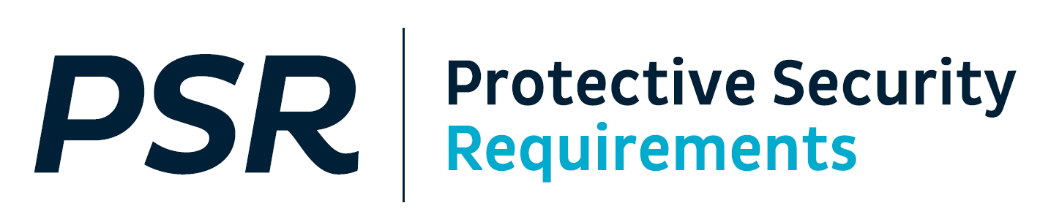

**PREPARE TO ASSESS YOUR PROTECTIVE SECURITY CAPABILITY 2023/24**

Kia ora koutou

The annual Protective Security Requirements (PSR) capability self-assessment round is now open.

Your Chief Executive is responsible for the self-assessment and final sign off of the report, which must be **submitted to the PSR Unit by 30 April 2024**.

Moderation of your self-assessment improves the quality and accuracy of your reporting. As always, we encourage you to have your self-assessment moderated.

*Below is a summary of what you need to know before you assess your capability this round. New document templates and guides are available for download from the PSR website.*

# Minor changes to the 2023/24 Self-Assessment Report

Based on your feedback we have made some minor changes to the current self-assessment reporting for 2023/24. The changes are aimed to reduce duplication, make it easier to understand what and how to report, and enable greater reporting consistency across agencies. We have made the following changes:

**There is a new set of INFOSEC questions that have been incorporated into the relevant mandatory requirement sections.**

The separate INFOSEC questions have been reviewed and updated by the National Cyber Security Centre. The updated questions are still integrated directly into the relevant mandatory requirements sections which are designed to specifically elicit the evidence needed this year.

**The PSR Self-Assessment Report Template (MS Word) has been updated with key changes. Your self-assessment must be submitted via email. The online portal is still not available.**

The updated PSR Self-Assessment Report Template includes formatting updates, the addition of targeted questions on the Classification Policy (INFOSEC 2) and the new MBIE Procurement Guidelines (GOV 5), additional instructions, and an optional [excel spreadsheet](https://www.protectivesecurity.govt.nz/assets/Governance/agency-supporting-documentation-2023-24.xlsx) for recording policy documentation.

*Importantly,* *the online portal will still not be used for submission of 2023/24 reports.* Please use the MS Word template to complete your self-assessment and for reports at RESTRICTED and below submit this via email to the PSR Unit via [psr@protectivesecurity.govt.nz](mailto:psr@protectivesecurity.govt.nz).

**The “How To” Guide has been updated with examples of what good evidence looks like.**

The guide was produced last year to demonstrate what is required to evidence the policy and practice for mandatory requirements. It provides real world anonymised examples. Combined with the updated PSR Self-Assessment Report Template, these tools should allow you to better understand what good evidence looks like. It should also improve consistency of reporting across agencies. This year it has been updated to align with the minor changes to the reporting template, and provide another model example in INFOSEC to reflect the change in the question set.

# What hasn’t changed?

**The Capability Maturity Model (CMM) assessment section of the PSR Self-Assessment Report Template is still in a separate Capability Maturity Assessment Template**.

The Capability Maturity Assessment Template is for your agency’s internal use when you undertake your CMM assessment. You must still undertake this capability assessment and summarise your findings in your self-assessment report, however you will not need to provide the detailed evidence in your self-assessment report. This will reduce some of the duplication you have experienced when reporting. You do not need to submit this.

# PSR Forum – 2023/24 Self-Assessment Reporting

We held a PSR Forum on Wednesday 11 October to discuss the system insights from the 2022/23 assurance round and specifically what you would need to know for the next PSR self-assessment round. Also discussed was the next phase of the PSR Assurance Project and how agencies can have a role in the redesign.

The briefing was held at RESTRICTED at Defence House.

# Looking ahead: PSR Assurance Project – Objective and Design Principles

The PSR assurance framework is intended to support agencies to manage their security risks and to provide assurance to Chief Executives, Government Protective Security Lead, Government Chief Information Security Officer and wider Government Leaders.

**It should help agencies to:**

* Identify protective security risks
* Assess how well they are managing those risks
* Make decisions on where to invest their marginal dollar
* Provide insights into organisation and system-level performance and gaps.

We have developed the design principles based on what you said you needed from any change. So this is how we will measure the success of the change.

* **Robust** – it will be rigorous, positioning you to effectively manage your risks; it will be risk-based and work for agencies of any size or risk, it will be reliable and produce results that can be trusted, and future focused – positions the framework for the future
* **Easy to use** – it will be clear – articulates what the requirements are and what good looks like; it is efficient and effective eliminating duplication, improving objectivity, and streamlines the process.
* **Actionable** – it is about the efficient and effective collection, analysis, and reporting of relevant qualitative (narrative) information and quantitative (measurable) information and the process provides meaningful insights that agencies can use to self-reflect and prioritise their efforts to address their largest risks. It will provide useful insights at the system-level that can help shape our PSR work programme to lift capability in the highest priority areas.
* **Well supported** – agencies are supported with quality guidance, tools, education, channels, and support to improve our collective understanding and application across the system.

**Timeframe for change**:

* **Plan & Design** - Right now through the end of the calendar year we are planning and designing the changes.
* **Develop & Consult** - From January to October 2024, we will be developing the draft changes, tools, and guidance and in consultation with you all.
* **Pilot** - In November 2024, we will begin the pilot of the updated framework with volunteer agencies to test our processes and learn from the initial round. This will inform any changes to the final framework and tools. All remaining agencies not on the pilot will continue to use the current framework for the 2024/25 year.
* **Implement** - From November 2025, we will aim to roll out the final assurance framework to all agencies, including support and education wrapped around the roll out.

The overall change programme for assurance will take three cycles, but you can expect to see early dividends in how we provide support to agencies – including through new or changed channels, education, guidance, and ways of working.

**What we need from agencies:**

* We welcome feedback on the proposed approach to improving PSR assurance.
* We are looking for volunteers to support the design work -- from both protective security practitioners and risk and assurance practitioners.
* We will be seeking agencies to take part in the pilot for the 2024-25 assurance round.

Please contact the PSR Unit with any feedback and if you want to volunteer to support the design work or potentially take part in the pilot.

If you have any further questions, please contact the PSR team on:

[psr@protectivesecurity.govt.nz](mailto:psr@protectivesecurity.govt.nz).

Ngā mihi nui ki a koe

Protective Security Requirements Team

cid:image003.png@01D8C783.1CCCB2D0